The Twelfth Annual Marshall Immersion Workshop

A Visionary Adventure across Continents:
George C. Marshall and the European Recovery Program

July 21- July 25, 2014

Open to High School Level American and Modern European* History Teachers and Supervisors.

Workshop Details

The George C. Marshall International Center at the Marshall House in Leesburg, Virginia is pleased to announce the twelfth annual Marshall Immersion Workshop, open to a limited number of high school level American and modern European history teachers and school system social studies supervisors.

Participants will experience the rare and special privilege of meeting at Marshall’s museum home, the Marshall House, in Leesburg, Virginia to learn more about Marshall's contributions to twentieth century history. Using video materials and a series of primary documents from the Truman Presidential Library and the Marshall Library, participants will gain a better understanding of the life and remarkable legacy of Secretary of State Marshall, specifically his significant role in securing the passage of the European Recovery Program (ERP). Participants will view engaging archival films originally created to promote the ERP in Europe (1947-1951), as well as the comprehensive PBS documentary “The Marshall Plan: Against the Odds.” The film’s researcher and co-producer, Linda Christianson, will be there to provide analysis and commentary.

A significant aspect of the workshop emphasizes Marshall’s use of diplomacy as a tool for rebuilding Europe after the war. Through a partnership developed with the United States Department of State, participants will have the unique opportunity to experience an afternoon of learning on-site at the department’s United States Diplomacy Center at the State Department in Washington, D.C. During the latter part of the workshop week, participants will spend two days at the George C. Marshall Museum and Library in Lexington, Virginia. This will be a rich experience, since participants will have the opportunity to delve into the comprehensive Marshall archive, studying original documents relating to some of his most important work. One such historic treasure is Marshall's personal copy of the June 5, 1947, Harvard speech outlining the key concepts of the ERP. Attendees will receive copies of primary documents and other materials that will be helpful in covering this important topic in the classroom. After reviewing select materials, attendees will be expected to offer ideas for further areas of study related to Marshall’s integral roles in twentieth century history.

Chief among the many outstanding components of the Marshall Immersion learning experience is the opportunity for interaction between American and European colleagues. The 2014 summer workshop will include participants from Germany and Austria. Participants will exchange ideas and perspectives on how the workshop content and materials might benefit their respective classroom instruction. All who have had this opportunity unanimously cited the experience of working with colleagues from across the Atlantic as milestones in their professional and personal lives.

The workshop convenes at 8:30 A.M., Monday, July 21 at the Marshall House in Leesburg, Virginia, and concludes on Friday, July 25 at 3:30 p.m. at the Marshall Museum and Library in Lexington, VA, before our return trip to Leesburg, VA.

Benefits and Requirements

Participants will receive:

Transportation, meals (excluding Tuesday evening, a free night for participants, as well as dinner on the evening of arrival on Sunday the 20th, and Friday evening the 25th, after the conclusion of the workshop), private room lodging for 6 nights while attending the workshop (July 20 through 25); teaching materials connecting Marshall’s leadership roles to select units of study, and recertification
points.

The applicant must:

1. Be a full-time teacher at the high school level who anticipates teaching two units of either US* or modern European history* classes in 2014-15, or who holds a position as a social studies supervisor within the school district represented, and, in all cases, will continue in the school system through the 2019-20 school year.

2. Attend the entire workshop, (8:30 A.M. Monday, July 21 through 3:30 P.M. on
Friday, July 25)

3. Before the workshop convenes, read a biography of Marshall, as well as several related articles. Copies will be provided in advance either by mail or electronically. On the first morning of the workshop, participants will discuss the relative value of these materials to their particular teaching situations;

4. Following the workshop, submit a short follow up paper describing the usefulness of
the workshop experience to his/her respective teaching situation.

Note: Participants coming from out of town must provide their own transportation to and from Leesburg, Virginia. Transportation will be provided for all travel during the workshop, including the return trip from Lexington.

While the workshop ends at 3:30 P.M. on Friday, July 25 in Lexington, Virginia, participants will not arrive back in Leesburg until approximately 7:30 p.m.

*You may teach other subjects besides “straight” US or European history that would make you eligible for participation, such as American History Since 1900; Diplomatic History of the US, and other courses that are appropriate to the workshop’s theme. If so, please note that and explain.

There is an application form at the end of this document. It contains instructions for how to submit it.

Please return your application (see below) by Friday, March 14, 2014. All applicants will be notified regarding placements in the workshop by e-mail on Friday, March 21.

To learn more about the sites where the workshop will take place, visit:

The George C. Marshall International Center website at www.georgecmarshall.org

The George C. Marshall Foundation website at http://www.marshallfoundation.org

The US Diplomacy Center at US Department of State website at http://diplomacy.state.gov.

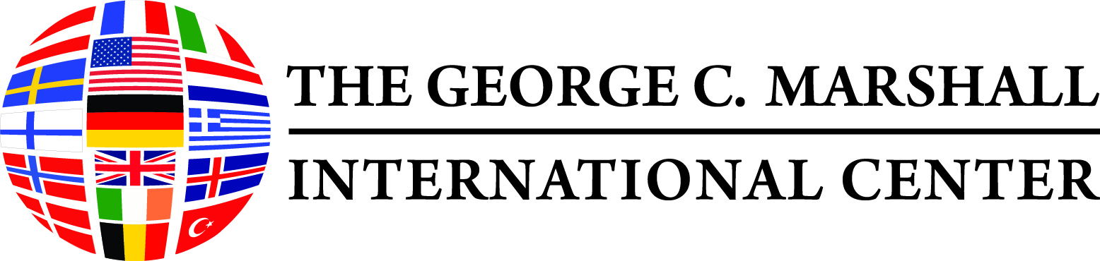
Application

Name: _________________________________________________________________________________

School:________________________________________________________________________________

School Address:_________________________________________________________________________

Home Address:__________________________________________________________________________

Phones: School__________________ Home__________________ Cell____________________
E-mail: ______________________________ (It is important that you list an e-mail address which you can access even after school is out of session.)

Please indicate how you learned about this workshop in the space provided:
______________________________________________________________________________________

______________________________________________________________________________________

As a separate file attachment, please provide a one-page essay describing your current teaching assignments, your reason for wanting to attend the workshop, and how you believe both you and ultimately your students will benefit from your participation. This essay will be helpful to us as we assess which applicants will find the workshop most useful to their respective teaching situations.

The deadline for applications is Friday, March 14, 2014; notification of acceptance is Friday, March 21, 2014.

Mail your application to the letterhead address, attention Carolyn Wyrsch (workshop co-director); or send it via e-mail to the address below with the subject line “Summer Workshop;” or, by fax to the Marshall House at 703 777-2889, attention Carolyn Wyrsch.

For further information about the workshop e-mail or call:

Carolyn Wyrsch, Workshop Co-director,
ciwyrsch@comcast.net, Phone 703 754-4831.

